**ST.LUKE BAANABAKINTU PRIMARY SCHOOL**

**QUALITY CHECK EXAMINATIONS 2024**

**Name:** _____________________________________________________________

**School: ____________________________________________**

**District: ____________________________________________**

# 

**In questions 1 – 10, fill in the blank spaces with the most suitable word.**

1. The driver _____________________ bus knocked a pedestrian has been arrested.
2. I have had a driving license ______________________ I was eighteen years old.
3. His phone rang ______________________ he was reading the magazine.
4. Our school has a big _____________________ from where we always borrow books.
5. In a newspaper, the main headline is always on the __________________ page.

**In questions 6 – 15, use the correct form of the word given in brackets to complete the sentences.**

1. The conductors should talk _______________________ to the passengers.

(polite)

1. Pemba was among the ____________________ who died in the accident.

(travel)

1. Kato will have _________________________ the puzzle by evening today.

(fill)

1. The tourists pushed the car by ___________________________. (self)
2. Jamal told us an ________________________ story about his journey to Mecca.(interest)
3. The tourists _________________ a lot of animals in the national park yesterday. (see)
4. The _________________ the tour guide gave us was very clear. (explain)
5. Our school choir sang very ____________ at the concert. (good)
6. I gave _________________ your books yesterday. (he)
7. Joan is ___________________ than her sister. (beautiful)

**In questions 16 and 17, arrange the words in alphabetical order.**

1. fare, care, dear, beer

______________________________________________________________

1. boat, boat, book, board

_______________________________________________________________ **In questions 18 – 20, give the plural form of the underlined word.**

1. I keep a diary in my drawer.

_______________________________________________________________ 19. The dentist removed her tooth.

_______________________________________________________________ 20. The mechanic will give you a piece of advice about your car.

_______________________________________________________________ **In questions 21 – 22, rearrange the given words to form correct sentences.**

1. the luggage has the carrier Meddie tied on.

_______________________________________________________________

1. remove a Why headlamp indicator and an did he?

______________________________________________________________ **In questions 23 – 24 use each of the given words in a sentence to show that you know the difference in their meaning.**

1. sell

_______________________________________________________________ 24. sale

_______________________________________________________________ **In question 25 – 27, rewrite sentence giving one word for the underlined group of words**

25. The departure time for the coach is 2:00 pm.

_______________________________________________________________

1. Work out: 21 x 4

1. Write ‘forty thousand five’ in figures.

1. Write the shaded fraction in the figure below.

|  |  |  |
| --- | --- | --- |
|  |  |  |
|  |  |  |

1. Complete the sequence below: 36 , 25 , 16 , 9 , ______

1. Find the missing number: +13 = 20

1. Draw a cylinder in the space below.

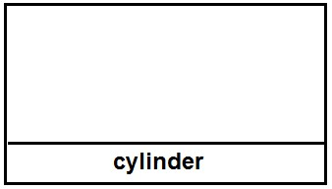

1. Express 36 in Roman numerals.

1. Peninah bought 4 pens at sh. 2000. How much money did she pay for each pen?



1. If shows 6 chairs. How many such pictures will show 48 chairs?

1. Write the unshaded region in the diagram.

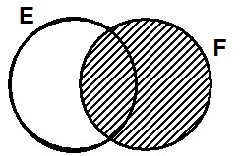

**Section B (60 marks)**

1. Given that set R = {The first 6 even numbers} and set S = { 1, 3, 6, 10, 15}.
2. List down all the elements of set R. **(1 mark)**

1. Represent the information above in the Venn diagram below. **(3 marks)**

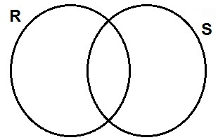

1. Find n(R U S). **(1 mark)**

12. Arrange ½ , 2/3 and 3/4 from the biggest to the smallest. **(5 marks)**

**Integrated Science**

1. How many main body parts does a butterfly have?

_________________________________________________________________ 2. State one way of administering vaccines.

_________________________________________________________________ 3. How is too much rain dangerous in the environment?

_________________________________________________________________ 4. Write down one non-communicable disease caused by poor feeding. _________________________________________________________________

1. What is the use of an iron box to a P.5 pupil?

_________________________________________________________________

**Pupils of Nkere Primary School were on a tour where the found the farm record shown below.**

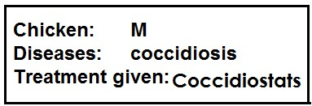

1. What time of farm record is shown above?

________________________________________________________________

1. Give the way in which shadows are formed.

_________________________________________________________________

1. If a coin and a jerrican are dropped into a water pool, why does a coin sink in water and the jerrican float on it?

_________________________________________________________________ _________________________________________________________________

10. Why do worker bees visit flowering plants?

_________________________________________________________________ 11. How can crops in a granary be protected from rats?

_________________________________________________________________ 12. What is the gestation period of a doe?

_________________________________________________________________

13. Why does the government of Uganda encourage its people to sleep under insect treated mosquito nets?

_________________________________________________________________ 14.

**Use the diagram below to answer questions 17 and 18.**

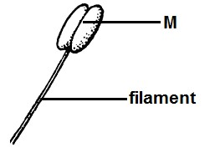

17. Name part M.

_________________________________________________________________ 18. What name is given to the part of a flower shown in the diagram above? _________________________________________________________________

**Section B (60 marks)**

42(a) Name one material used by bees to make honey.

_________________________________________________________________ (b) How do worker bees protect the hive?

_________________________________________________________________ (c) How are bees important to crops?

_________________________________________________________________

(d) Mention the type of bee that develops from unfertilized eggs.

_________________________________________________________________

43. **Study the diagram below and use it to answer questions below.**

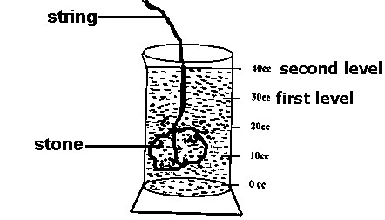

1. Name the method of finding volume shown in the diagram.

_________________________________________________________________

1. What is the volume of the stone in the measuring cylinder?

_________________________________________________________________

1. Find the mass of the stone in the measuring cylinder if it has a density of 4g/cc.

_________________________________________________________________

(c) Suggest one disadvantage of the system you have named in (a).

_________________________________________________________________

45(a) Mention one sign of a compound fracture.

________________________________________________________________

(b) How are the following structures useful in giving first aid?

1. arm sling

_________________________________________________________________

1. stretcher

_________________________________________________________________

(c) State the main reason for giving first aid.

_________________________________________________________________

46(a) State one danger of poor hygiene.

_________________________________________________________________

(b) Mention any two items a P.5 pupil used to clean his/her classroom.

1. _________________________________________________________________
2. _________________________________________________________________ (c) Give the importance of a dustbin in a P.5 classroom.

_________________________________________________________________

51. **The diagram below is a section through an onion.**

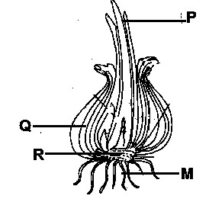

(a) Name the part marked R.

_________________________________________________________________ (b) How is the function of leaves marked P different from those marked Q? _________________________________________________________________

(c) Name the type of roots marked with letter M.

_________________________________________________________________ (d) How are onions propagated?

________________________________________________________________

**Social Studies and Religious Education**

**SECTION A:**

1. Write down any one group of people who use a compass in their daily work.

________________________________________________________________

1. How does the police maintain law and order in Uganda?

_________________________________________________________________ 3. Write NFA in full.

_________________________________________________________________ 4. What name is given to the steep slopes of a rift valley?

_________________________________________________________________ 5. How can children maintain security at school?

_________________________________________________________________

1. In the space below draw a map symbol of a canal.

1. Give one reason why Uganda is divided into many districts?

_________________________________________________________________ 8. Mention one way Port Mombasa is important to Uganda’s economy.

_________________________________________________________________

_________________________________________________________________ 9. Which natural vegetation is suitable for establishment of game parks?

_________________________________________________________________ 10. How is lake Katwe economically important to Uganda?

_________________________________________________________________

11. Why are people not advised to settle on the slopes of active volcanoes?

_________________________________________________________________

_________________________________________________________________ 12. Give any one problem faced by people in Kalangala and Buvuma districts.

_________________________________________________________________

**For questions 36 – 40, answer Christianity or Islam “BUT NOTE” both.**

1. **Either:** Who led the Israelites out of Egypt?

_________________________________________________________________ **Or:** Who led the Banisraelites out of Misiri?

_________________________________________________________________ 37. **Either:** What is a prayer?

_________________________________________________________________

**Or:** What is Salat?

_________________________________________________________________

_________________________________________________________________ 38. **Either:** Why should Christians pay the tithe?

_________________________________________________________________ **Or:** Why do Muslims pay zakat?

_________________________________________________________________

**SECTION B: (60 marks)**

42(a) What is the largest fish caught in Uganda’s lakes?

_________________________________________________________________ (b) How does fish smoking affect the environment?

_________________________________________________________________ (c) Write down any two local methods of catching fish.

47. **Study the map of Uganda and answer questions that follow.**

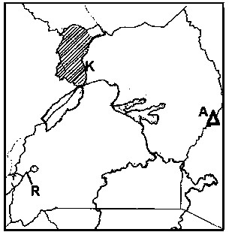

(a) How was mountain labeled A formed?

_________________________________________________________________ (b) What name is given to the feature shown with letter R?

_________________________________________________________________ (c) Write down any one district found in the shaded area.

_________________________________________________________________ (d) Name the part of river Nile labeled K.

_________________________________________________________________

48(a) What is child abuse?

_________________________________________________________________ (b) Give two ways children’s rights are abused in Uganda today

(c) How can the government of Uganda fight the habbit of child abuse in Uganda?

_________________________________________________________________

_________________________________________________________________